ANNEX B

ABOUT THE ARTISTIC TEAM

Shubigi Rao, Artist

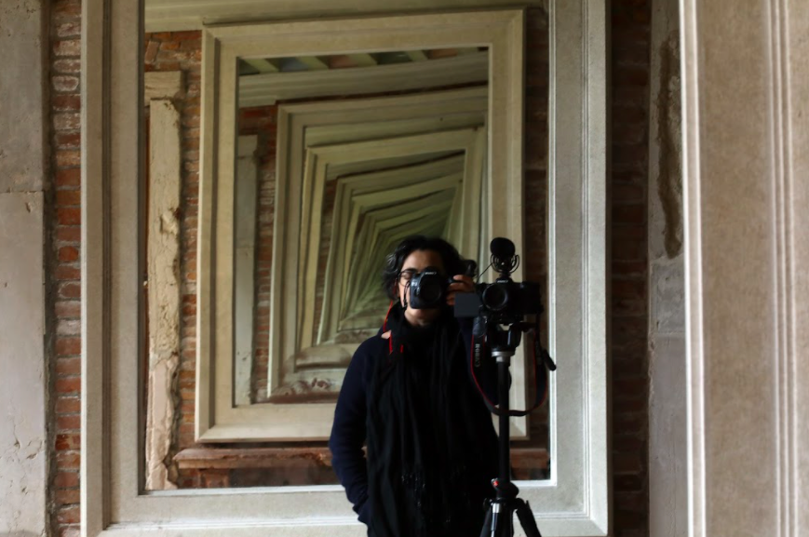

Artist and writer Shubigi Rao’s fields of study include libraries, archival systems, histories and lies, literature and violence, ecologies and natural history. Her art, texts, films, and photographs look at current and historical flashpoints as perspectival shifts to examining contemporary crises of displacement, whether of people, languages, cultures, or knowledge bodies. As an artist, Rao’s films, art, texts, and photographs have critically, poetically and wittily examined the systems of knowledge that structure our world. In 2008, she received her MA in Fine Arts from Lasalle College of the Arts in Singapore. Since 2014 she has been visiting public and private collections, libraries and archives globally for her 10-year project titled Pulp: A Short Biography of the Banished Book. As an artist in residence at NTU Centre for Contemporary Art Singapore, Gillman Barracks, she released her first book from the project in January 2016. It was shortlisted for the biennial Singapore Literature Prize 2018 (non-fiction). The second book from the series released in 2018 won the Singapore Literature Prize (non-fiction) in 2020. Both publications have won numerous awards, including AIGA (New York)’s 50 best books of 2016 and 2018, and D&AD Pencil for design (2016, 2018). The first exhibition of the project, Written in the Margins, won the APB Signature Prize 2018 Juror's Choice Award. Rao has also been featured in 10th Asia-Pacific Triennial (2021), March Meets (2019), 4th Kochi-Muziris Biennale (2018), 10th Taipei Biennial, (2016); 3rd Pune Biennale (2017), and 2nd Singapore Biennale (2008). She is currently the curator for the upcoming Kochi-Muziris Biennale in 2022.

Ute Meta Bauer, Curator

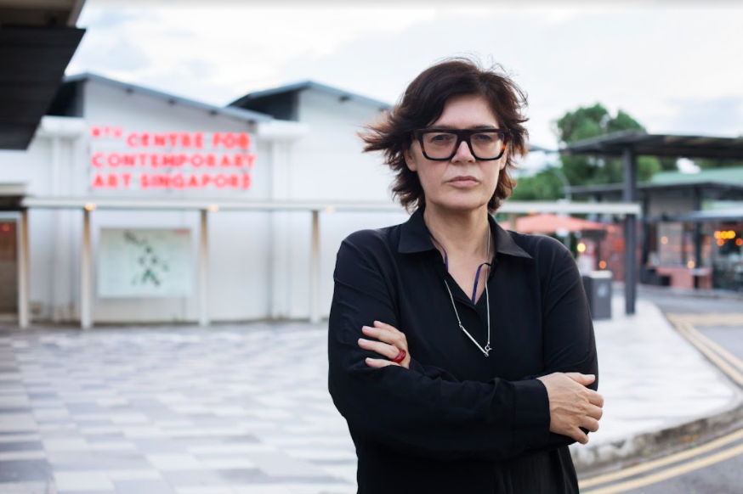

Photo: Christine Fenzl

The 10th edition of the Singapore Pavilion is curated by Ute Meta Bauer, curator of exhibitions and presentations that connect contemporary art, film, video and sound through transdisciplinary formats. Since October 2013, she has been the Founding Director of NTU Centre for Contemporary Art Singapore (NTU CCA), a research centre of Nanyang Technological University (NTU) where she is a full professor in the School of Art, Design and Media (ADM), and where she has curated and co-curated numerous exhibitions, most recently Non-Aligned (2020), featuring artists John Akomfrah, Naeem Mohaiemen and the Otolith Group, and Trinh T. Minh-ha. Films (2020/2021). In 2015, she co-curated with Paul Ha, the Visual Art Director at MIT List Centre, the U.S. Pavilion at the 56th International Art Exhibition of La Biennale di Venezia, presenting eminent artist Joan Jonas. Bauer’s current research focus is on “Climate Crisis and Cultural Loss”. She was an expedition leader of TBA21-Academy’s The Current (2015–2018), exploring the Pacific Archipelago and littorals most impacted by climate change and human interventions, and is the editor of Climates. Habitats. Environments., co-published by NTU CCA Singapore and MIT Press (forthcoming March 2022).

