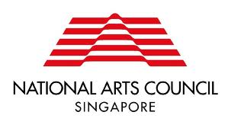
Research Grant: Mid-Term Report
Date of Submission of Mid-Term Report
Name of Organisation
(if applicable)
Name of Principal Investigator
Project Title
Project Dates | Start
 | End

We would like you to share a mid-term status update on your project with us. You may wish the use the following questions as a guide. Please include other attachments if applicable.

Status Update on Project
- Is the project on track?
- What were some challenges faced so far in the course of the research project and how did you overcome them?
- Please attach interim project income and expenditure with the budget form submitted as part of the grant application.
Remaining Project Milestones
- Are there changes to project timelines or deliverables?

For grants awarded in FY20 and before

Please email this Mid-Term Report and budget form submitted as part of the grant application, with interim income and expenditure reflected to your account manager indicated in the Letter of Offer.

Alternatively, these documents may be submitted via email to: NAC_Researchdevt_grant@nac.gov.sg. Hardcopies may be directed to:

National Arts Council
Research Grant
90 Goodman Road
Blk A #01-01
Singapore 439053

Opening Hours:
Monday to Friday, 9am – 12pm and 2pm – 5pm.

For grants applied through the Our SG Grants Portal

Please log onto the Our SG Grants Portal to submit your Final Research Report, Self-Evaluation Report, Financial Report (i.e. the budget form submitted as part of the grant application, with actual income and expenditure reflected).

