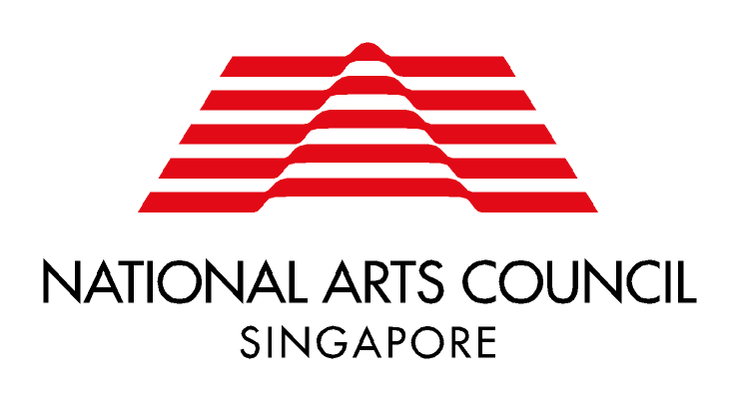
FOREIGN ARTISTIC TALENT SCHEME
APPLICATION FOR SINGAPORE PERMANENT RESIDENCE

Please complete this form in English, and submit it together with your Curriculum Vitae (CV) to NAC.

- PERSONAL PARTICULARS
Full Name
Nationality
Mailing Address
Email
Contact Number (main)
Website (if any)
Type of Work Pass in Singapore | Employment Pass S Pass Work Permit Entrepass  Issued on: (DD/MM/YY) Valid until: (DD/MM/YY)
- KEY INVOLVEMENTS IN SINGAPORE’S ARTS & CULTURAL SECTOR (Please include past engagements as well as concrete future projects for which you have been and will be involved in a leadership role)
*Please attach additional papers if space provided is insufficient
Period of Project | Project Title and Brief Description | Role Played

- PERSONAL STATEMENT
*Please attach additional papers if space provided is insufficient
In your personal statement, please outline:
- Your purpose for applying for Singapore Permanent Residency status;
- Your professional goals and the role you will play in advancing Singapore’s arts and cultural scene; and
- Your action plans in helping you succeed in the role you have described above.
1 May 2013

