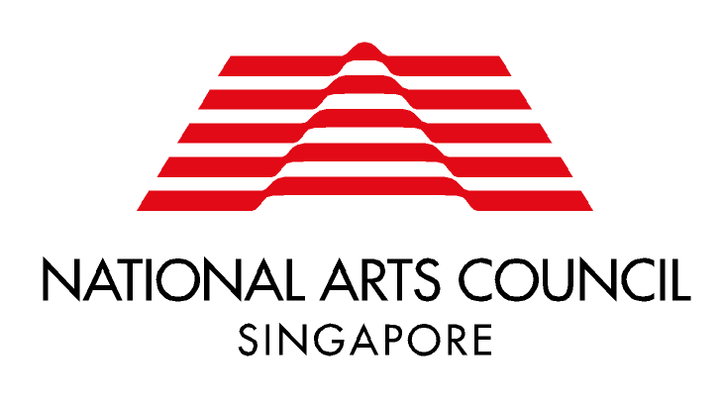
YOUNG ARTIST AWARD GRANT
APPLICATION FORM

Please complete in BLOCK letters. No space in the form should be left blank. Insert 'NA' or 'NIL' where applicable.

I PARTICULARS OF PROJECT
Title of Project:

Project Description:

Grant Requested (see application guidelines): S$ | Total Cost of Project: S$
Project Start Date (day/month/year) | Project Completion Date (day/month/year)
II PARTICULARS OF APPLICANT
Name of Applicant |  | NRIC | Nationality
Address |  | Date of Birth | Age
 |  | Tel (Home) | Tel (Office)
Email |  | Mobile | Fax
III DECLARATION

I certify that the information given above and in the attached Proposal and Budget Forms are to the best of my knowledge and belief, true and complete. I agree to abide by the terms and conditions governing the application for the Grant.

Signature of Applicant : ________________________

Name of Applicant : _________________________

Date : _________________________

18 Nov 2011

