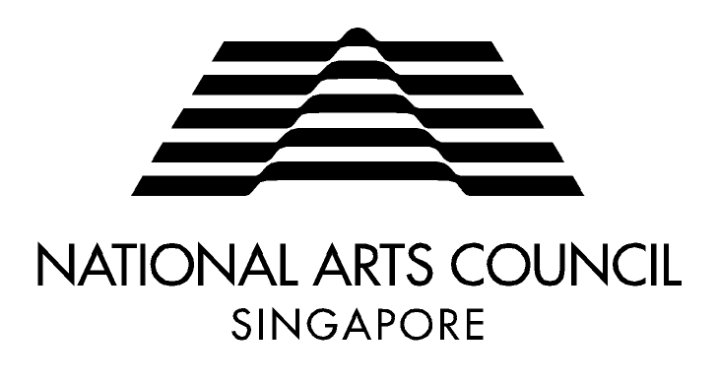
PUBLIC ART TRUST
SUBMISSION OF PUBLIC ART PROPOSAL: CO-COMMISSION APPLICATION

It is mandatory for the applicant to complete this form in black type or written legibly in PRINT to facilitate duplication.

SECTION 1 – APPLICANT INFORMATION
Name of Company / Organisation: UEN / Professional Registration No.:

_____________________________________ _____________________________________

Website: Date of Incorporation:

_____________________________________ _____________________________________

Address: Primary Contact:

_____________________________________ _____________________________________
Full Name
_____________________________________
_____________________________________
_____________________________________ Designation / Department (if any)
Postal code Country (_____)______________ (_____)______________
Telephone (Office) Mobile
(_____)______________
Fax (Office)

__________________________________________
Email
Company / Organisation Profile:

SECTION 2 – ARTIST INFORMATION
Name (please provide full name as in NRIC): Mrs. Miss Mr.

__________________________________________________(_________________)
Surname Given names NRIC number

Date of Birth: Nationality:
Singaporean
_____________________________________ Permanent resident __________________
dd/mm/yyy Age (Please indicate nationality)

Permanent Address: Contact Details:
_____________________________________ (_____)____________ (_____)____________
Block / house number & street name Telephone (Residence) Mobile

_____________________________________ (_____)____________
Apartment / unit number (if any) Fax (if any)

__________________________________________ ________________________________________
Postal code Country Email

SECTION 3 – SITE INFORMATION
Location of Site: Ownership of Site:
Owned by Company / Organisation
_____________________________________ State Land
Owned by Other __________________
_____________________________________ (Please indicate ownership)
Street Address No site proposed
(If so, please indicate requirements of preferred site below)
__________________________________________
Postal code (if any)

Site Specifications: Public Accessibility:

_____________________________________ ________________________________________
Type (Indoor / Outdoor) Accessible Hours

__________________________________________ ________________________________________
Size (L/W/H) Proposed duration of Display
Description / Background of Site:
(E.g. Any notable landmarks, historical or social significance)

SECTION 4 – PROPOSED CONCEPT
In no more than 2 A4 pages, single-spaced, please attach an outline of the artistic concept / statement and a description of the proposed idea / concept, including images / schematics where applicable.

SECTION 5 – SUPPORTING MATERIAL
Check that you have enclosed the following supporting material as specified in the guidelines, together with this application form:

Artwork proposal ;

Drawings, plans, images/photographs of proposed site (if applicable);

Drawings, plans, 3D rendering or maquette (optional) of proposed work;

Artwork installation, and conservation / maintenance plan;

Proposed budget {please use budget template provided };
Artist’s CV and samples of past work.

Please send your completed application to the Public Art Trust at:

National Arts Council – Public Art Trust
90 Goodman Road
Goodman Arts Centre
Blk A #01-01
Singapore 439053

For enquiries, please contact Desiree Tan at Email: desiree_tan@nac.gov.sg / Tel: 6346 9492

