
User Guide for Instructor Registration (2026 Cycle)
NAC-AEP E-Services Portal
Updated in October 2025
Contents

About Instructor Registration  Key Dates ……………………….…………………………………………….………………………………………………………. | 3  3
Before You Start  New NAC-AEP Instructor Registration | 4  5
Registration Process  Register as Instructor ……….………………………………………………………………………….…………….………  Portfolio ……….………………………………………………………………………….…………….………………………....  Art Form Qualifications ……………………………………………………………………………………………………...  - Formal Qualifications …………………………………………………………………………………………………  - Other Qualifications …………………………………………………………………………………………………..  - Industry Experience ……………………………………………………………………………………………………  Teaching Experience ………………………………………………………………………………………………….………  Pedagogy Training ……………………………………………………………………………………………………..………  Awards and References ……………………………………………………………………………………………..………  Final Steps …………………………………………………………………………………………………………………………..  Annex A – Art Form Sub-Genre List ……………………………………………………………………………………. | 8  9  11  12  14  16  17  20  21  23  26


About Instructor Registration for NAC-AEP 2026 Cycle

Instructors who will be engaged by providers to conduct approved 2026 National Arts Council-Arts Education Programme (NAC-AEP) are required to be registered in the NAC-AEP E-services Portal.

This document will guide instructors in registering and submitting portfolios.

Key Dates
November 2025 | Notification of Successful Applications and Instructor Registration  Upon NAC’s notification to all providers of the status of their NAC-AEP applications, instructors of approved programmes need to register in the NAC-AEP E-services Portal.  Instructors need to fulfil the art form expertise, teaching experience and pedagogy training requirements for mainstream, SPED and preschool programmes as stated under Instructor Credentials in the Assessment Criteria to conduct the approved programmes. Providers will subsequently tag the relevant registered instructors to their approved programmes.
December 2025 | Notification of Directory Go-Live  Programmes with approved content and minimum number of instructors required to conduct the programme will be published on the NAC-AEP Directory.

Before You Start

Important Information
- Instructors will need to register directly on the NAC-AEP E-services Portal to be eligible to conduct NAC-AEP in schools.
- Instructor accounts are used to submit and manage portfolios.
- You will need a SingPass account to register for an account. If you do not have a valid SingPass ID, please register for one via the SingPass Portal.
- Each instructor can have only one account.
- Upon successful registration, instructor will be able to submit a portfolio to demonstrate art form expertise, teaching experience and pedagogy training.​
- Please read our Privacy Statement for NAC's data management policy.

Reading up in advance

In addition to the NAC Arts Education Framework, please read the Registration Process outlined in this guide before proceeding to register an account and submit portfolio.

Instructors should:

Ensure that they fulfil the art form expertise, teaching experience and pedagogy training requirements for mainstream, SPED and preschool programmes as stated under Instructor Credentials in the Assessment Criteria document before submitting an online registration. By registering and submitting the portfolios, applicants would have read and accepted all the Terms and Conditions of NAC-AEP.

- Prepare in advance the information required for registration by referring to the Sample Instructor Registration Form. Information would include:
- Art Form Qualification(s)
- Teaching Experience(s)
- Pedagogy Training

Prepare the following:
- A recent photograph (up to 200kb)
- Certificates and/or documentation of qualifications
- Awards and/or references (if any)

- The application process will take approximately 45 minutes.

- You are required to submit your portfolio after you have registered for an instructor account.

- You will be notified via email on the status within 2 weeks of your submission.

- NAC will contact you if additional information and/or clarification is required.

- Instructors with submitted portfolios will be included in the Instructor Database and can accept or decline offer(s) by providers to conduct NAC-AEP(s).

- Save your draft portfolio regularly to avoid potential loss of data during the registration process. You can also opt to save and continue working on your draft portfolio later by clicking the ‘Save and Continue Later’ button.

- Review your portfolio before clicking the ‘Submit’ button. Draft portfolio will not be considered as submitted.

New NAC-AEP Instructor Registration
- Navigate to NAC-AEP Directory website and click on the ‘Login’ menu at the top right corner. You will be brought to the Registration page.
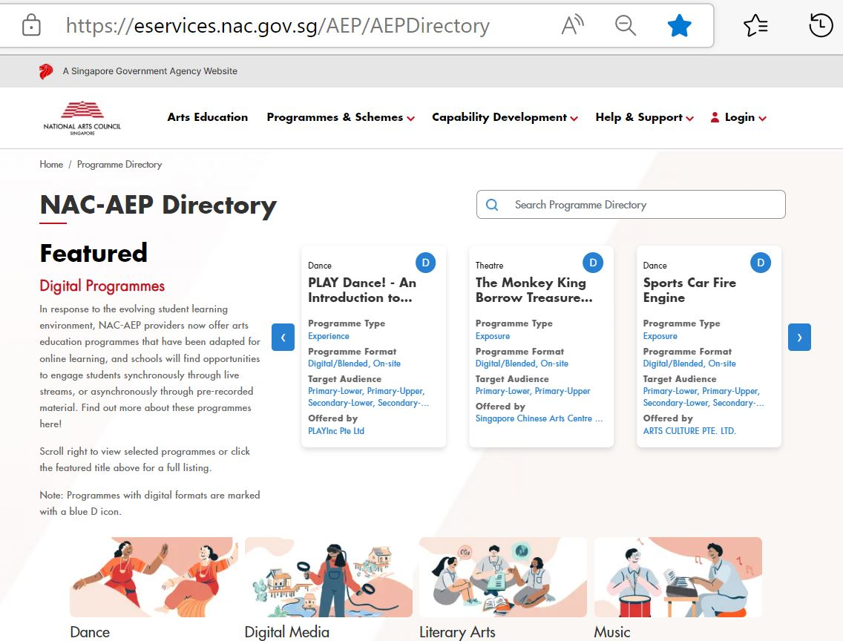
Fig.1 NAC-AEP Directory

- Click on the ‘Instructor’ tab and read the information displayed.
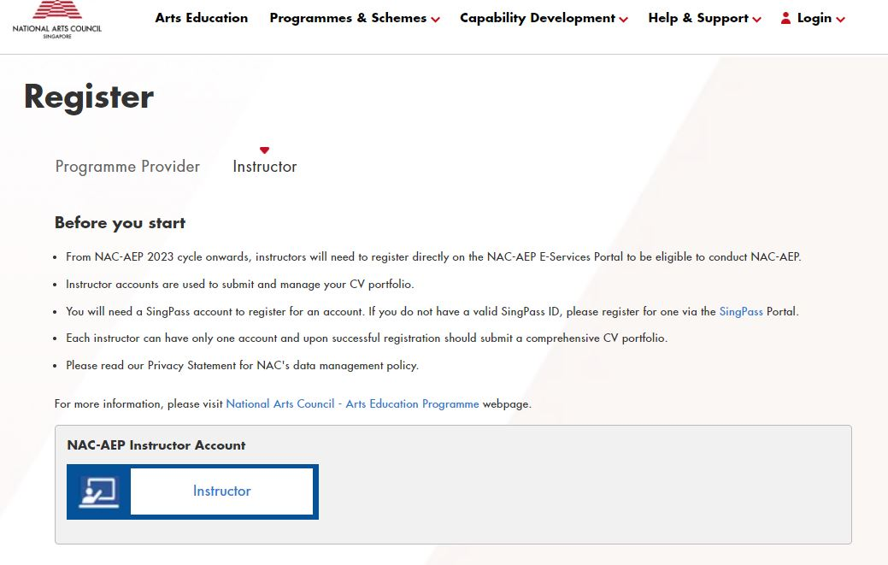
Fig. 2 Login Page
- Log in with Singpass
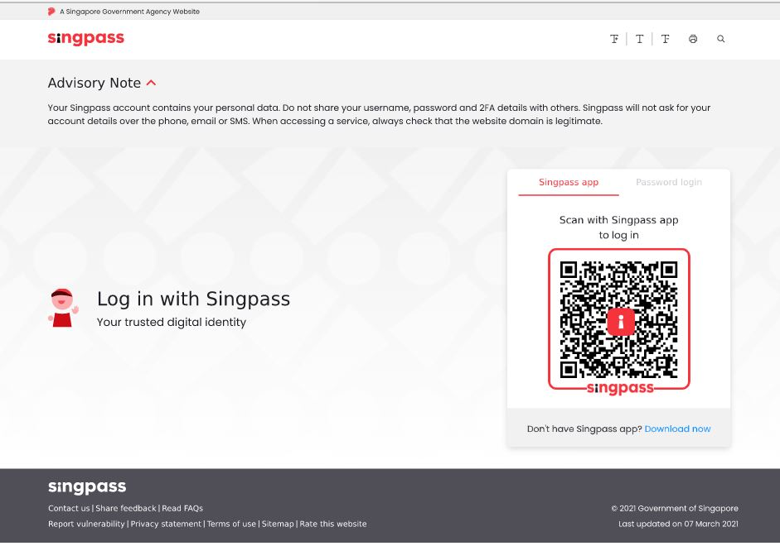
Fig. 3 Log in with Singpass Page
- After a successful log in, you will be brought to Welcome and Confidentiality and Privacy of Personal Information page. Read the information and click on the acknowledgement before submitting any data.
- Click ‘Start Registration’. You will then be brought to the Register as Instructor page.
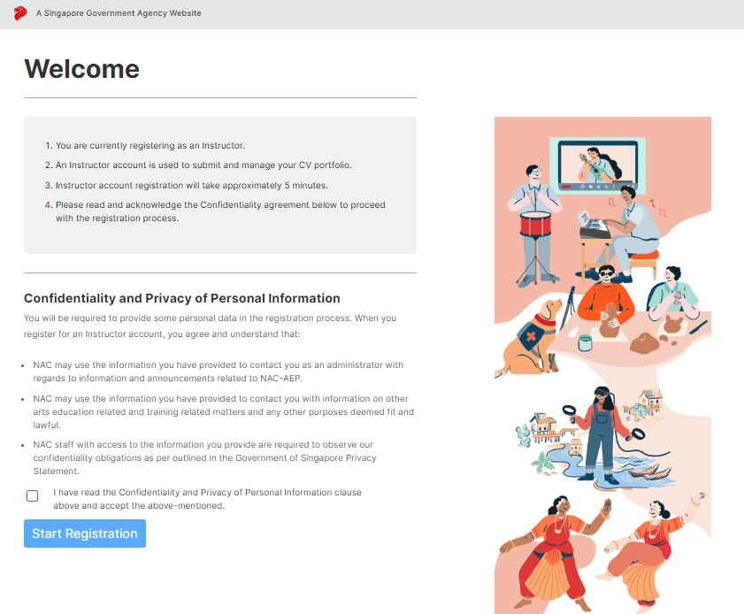
Fig.4 Welcome Page
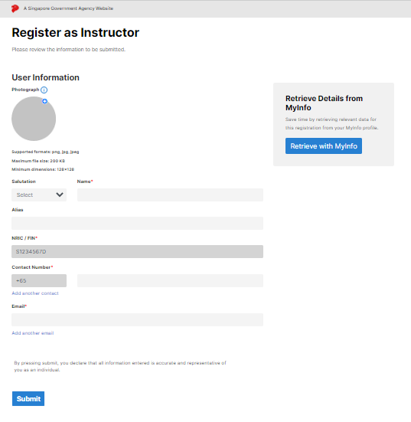
Fig. 5 Register as Instructor Page

Register as Instructor
User Information
You may wish to retrieve your details and information using the ‘MyInfo’ button. Alternatively, details may be entered manually. Entries with a red star (*) are mandatory information.

Ensure your details are correct and click on ‘Submit’. You will be brought to the ‘Registration Submitted’ page.

Registrations are auto-approved. Click on the ‘Go to Dashboard’ button on the ‘Registration Submitted’ page to be re-directed to your instructor dashboard.

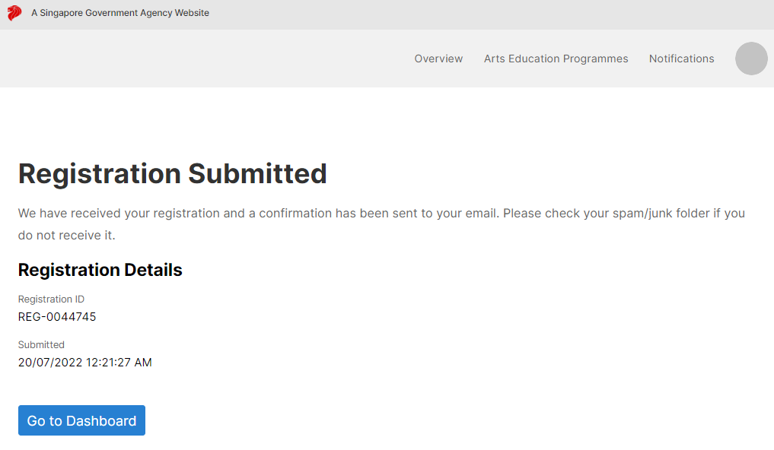
Fig.6 Acknowledgement of Submission

Dashboard
From the Dashboard, you may edit your particulars or add your portfolio. When clicking on the ‘Edit Personal Particulars’ button, a popup window will appear for you to edit any details. Once done, click on ‘Save and Exit’, and you will be brought back to the Dashboard.

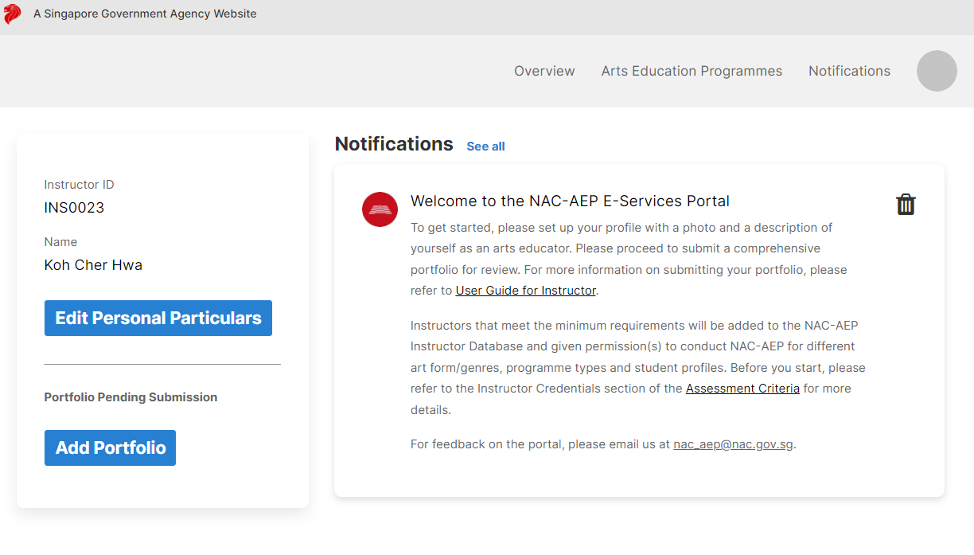
Fig.7 Dashboard
- Photograph
You may upload a recent professional photograph of yourself. Images should be in PNG, JPG or JPEG formats, and be a maximum size of 200kb. Minimum dimensions are 128x128. To upload, click on the blue ‘+’ icon.

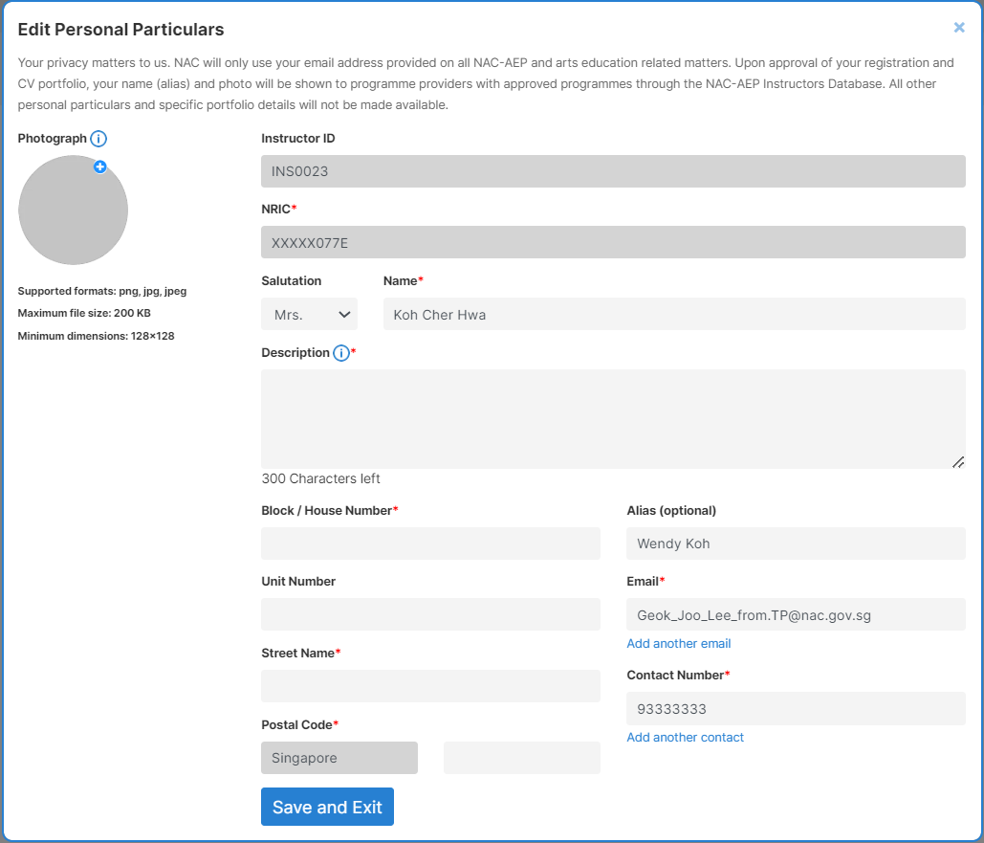
Fig.8 Edit Personal Particulars

Portfolio
Back on the Dashboard, click on ‘Add Portfolio’ and a popup ‘Before you start’ will appear. Agree to the terms and conditions of NAC-AEP by checking the box and click on ‘Start Application’. You will be brought to the ‘Portfolio’ tab.

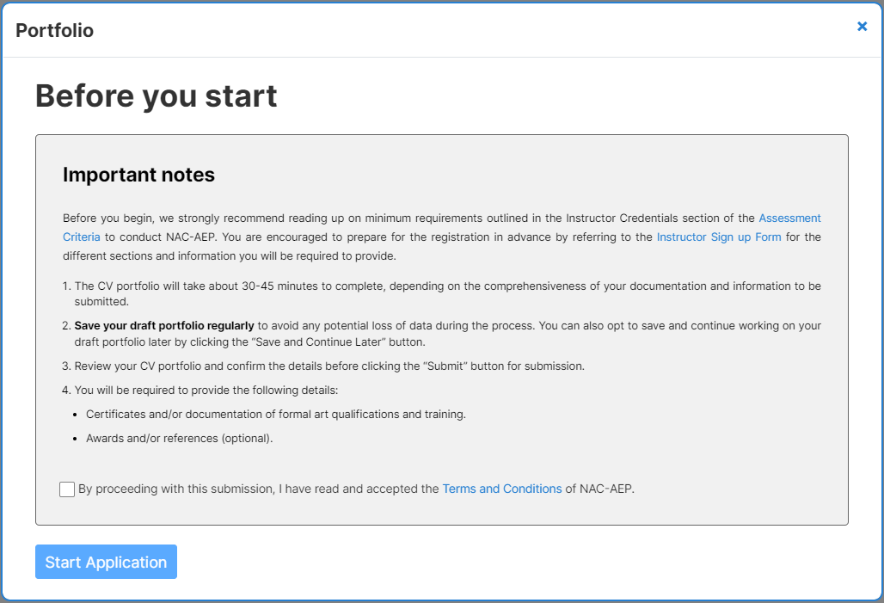
Fig. 9 Before You Start/Important Notes Pop-Up

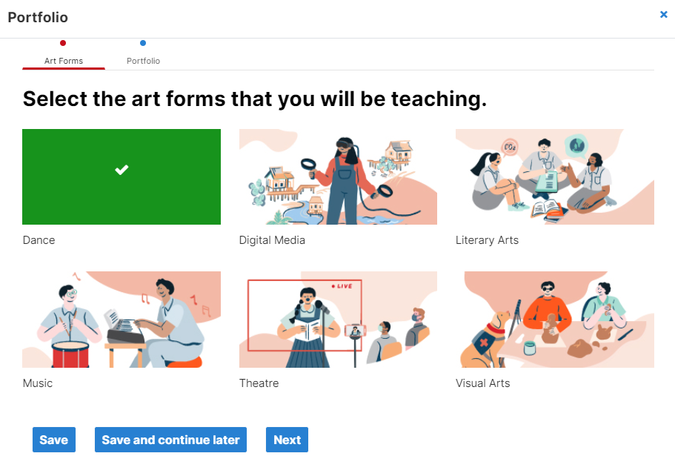
Fig.10 Art Form Selection

Select the Art Form(s) that you will be teaching. Selected Art forms will be highlighted in green. You may select more than one. For each Art Form selected, you will need to provide information on relevant qualifications and teaching experience. Click ‘Next’.
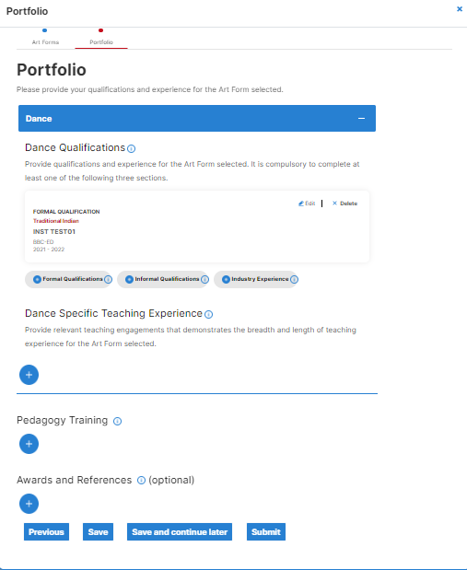
Fig.11 Portfolio

Art Form Qualifications
This section is for you to indicate relevant formal qualifications (Diploma/Degree issued by Educational Institutions), other qualifications (accumulative training with art form experts/organisations or short courses) and/or industry experience (practising the art form/working in the industry). You will need to complete at least one of the categories (i.e. Formal Qualifications, Other Qualifications and/or Industry Experience).

- Formal Qualifications
Formal Qualifications are awarded by accredited institutions for successful completion of a rigorous programme, and usually requires candidates to pass an exam associated with the course. E.g. ABRSM, RAD, ISTD, etc. To go back without saving, click on the blue ‘x’ button at the top right corner.
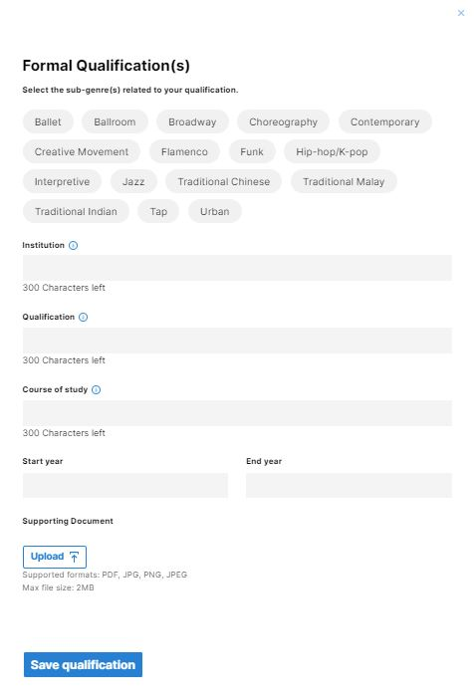
Fig.12 Formal Qualifications
- Subgenre
Refer to Annex A for a list of subgenres for each Art Form.
- Institution
Institution refers to the organisation where you obtained your qualification from, e.g. LaSalle, Nanyang Academy of Fine Arts, School of the Arts Singapore, etc.

- Qualifications
This refers to the type of qualification obtained, e.g. Diploma, Bachelor’s degree, Certificate, Postgraduate study, etc.
- Course of Study
Course of Study refers to the curriculum or programme you have been qualified for, e.g LASALLE Diploma in Fine Arts, ABRSM practical/ theory grade 8 etc.
- Start and End Year
Enter the commencement and end dates of the course of study.
- Upload of Supporting Documents
Please attach/upload a copy of your certificate(s) by clicking on the blue ‘Upload’ button. Supported formats: PDF, JPG, PNG, JPEG. Max file size: 2MB.
Remember to save your details/progress by clicking on the ‘Save Qualifications’ button. You will be brought back to the Portfolio page. A summary card of your details will be displayed. To make edits, click on the ‘Edit/pencil’ icon.
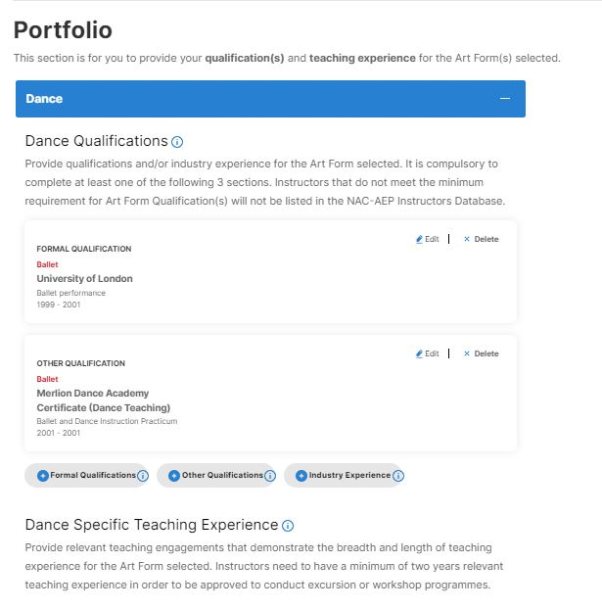
Fig13. Summary Cards on Portfolio Tab
- Other Qualifications

Other Qualifications are typically short-term courses that allow for further development and may or may not come with a certificate. E.g. Intensive masterclasses in a specific skill.

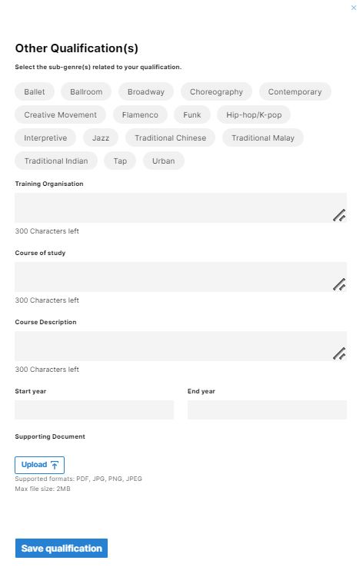
Fig.14 Other Qualifications

- Subgenre
Refer to Annex A for a list of subgenres for each Art Form.
- Training Organisation
Training Organisation refers to the company/organisation where you had undergone the course or masterclass etc.

- Course of Study
Input the full name of the programme/course of study. This refers to the type of qualification obtained, e.g. Diploma, Bachelor’s degree, Certificate, Postgraduate study, etc, if any.
- Course Description
Provide a short description of the course with details relevant to the Art Form/Subgenre.
- Start and End Year
Enter the commencement and end dates of the course of study.
- Upload of Supporting Documents
Please attach/upload a copy of your certificate(s) by clicking on the blue ‘Upload’ button. Supported formats: PDF, JPG, PNG, JPEG. Max file size: 2MB.
Remember to save your details/progress by clicking on the ‘Save Qualification’ button. You will be brought back to the Portfolio page. A summary card of your details will be displayed. To make edits, click on the ‘Edit/pencil’ icon.

- Industry Experience

Industry Experiences are professional engagements through which an individual’s services were engaged formally. E.g. Performer for production, stage crew, judge for competition etc.

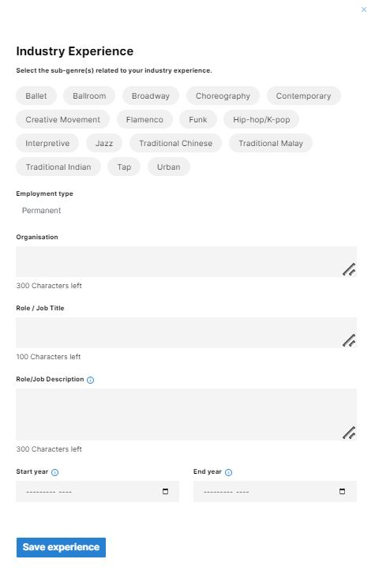
Fig.15 Industry Experience

- Subgenre
Refer to Annex A for a list of subgenres for each Art Form.
- Employment Type
Select the type of employment (e.g. Permanent, Temporary, Freelance etc).
- Organisation
Input the company/organisation that provided the employment.

- Role/Job Title
Provide the role/job title.
- Role/Job Description
Provide a clear and concise description of your job role, responsibilities and skills demonstrated, with specific emphasis on your work in education.
- Start and End Year
Enter the commencement and end dates of the employment.
- Upload of Supporting Documents
Please attach/upload a copy of your certificate(s) by clicking on the blue ‘Upload’ button. Supported formats: PDF, JPG, PNG, JPEG. Max file size: 2MB.
Remember to save your details/progress by clicking on the ‘Save Experience’ button. You will be brought back to the Portfolio page. A summary card of your details will be displayed. To make edits, click on the ‘Edit/pencil’ icon.

Teaching Experience

This section is for you to indicate relevant teaching experience(s) working with different student profiles, programme types (description of breadth of programmes taught) and teaching duration (length of time or estimated hours) of the Art Form selected. Indicate your relevant teaching experiences to date.

As stated in Instructors Credentials, instructors should have at least two years of relevant teaching experience to conduct talks, excursions and workshop programmes in mainstream schools, special education sector and preschools.

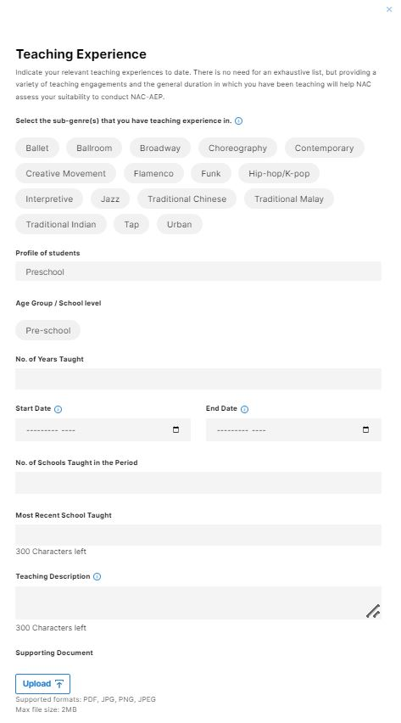
Fig.16 Teaching Experience

- Subgenre
Refer to Annex A for a list of subgenres for each Art Form.
- Profile of Students
Profile of students taught (Preschool, Primary Lower, Primary Middle etc).
- Age Group/School Level
Input the age groups of students taught (e.g. 12-13).
- No. of Years Taught
Provide the number of years of experience teaching the art form.
- Start and End Year
Enter the commencement and end dates of the teaching experience.
- Most Recent School Taught
Provide the name of the most recent school taught.
- Teaching Description
Describe the types of programmes conducted, the student groups interacted with (e.g. CCA, after-school programmes) and/or experience teaching in different modes (i.e. digital, asynchronous, etc.).
- Upload of Supporting Documents
Please attach/upload a copy of your certificate(s) by clicking on the blue ‘Upload’ button. Supported formats: PDF, JPG, PNG, JPEG. Max file size: 2MB.
Remember to save your details/progress by clicking on the ‘Save Experience’ button. You will be brought back to the Portfolio page. A summary card of your details will be displayed. To make edits, click on the ‘Edit/pencil’ icon.
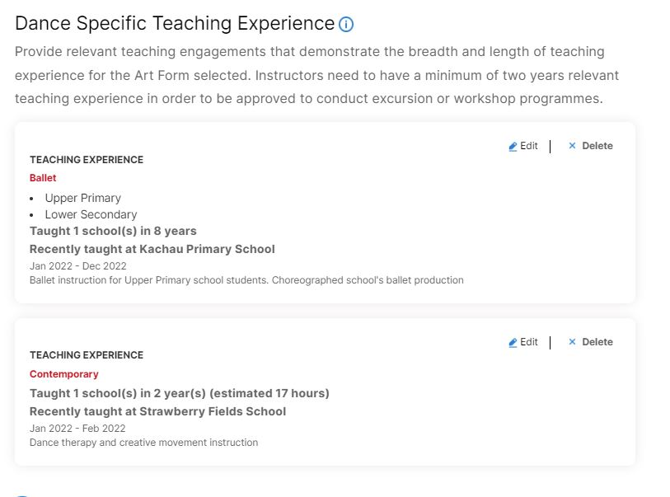
Fig. 17 Teaching Experience Summary Cards

- Pedagogy Training

This section is for you to illustrate any relevant pedagogical qualifications. This can include baseline pedagogy training courses offered by local training institutions (E.g. NIE – Essentials of Teaching and Learning) or other equivalent training that cover topics on teaching and learning strategies, classroom management, assessment evaluation, facilitation skills and lesson planning for the relevant student profiles.
As stated in Instructor Credentials, instructors conducting workshop programmes in mainstream schools, SPED schools and preschools need to fulfil this criterion.

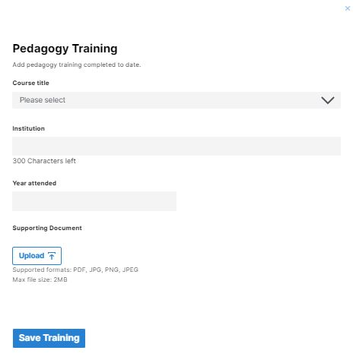
Fig.18 Pedagogy Training

- Course Title
Provide the name/title of the course.
- Institution
Provide the name of the institution attended.
- Year Attended
Provide the year(s) attended.
- Upload of Supporting Documents
Please attach/upload a copy of your certificate(s) by clicking on the blue ‘Upload’ button. Supported formats: PDF, JPG, PNG, JPEG. Max file size: 2MB.
Remember to save your details/progress by clicking on the ‘Save Training’ button. You will be brought back to the Portfolio page. A summary card of your details will be displayed. To make edits, click on the ‘Edit/pencil’ icon.
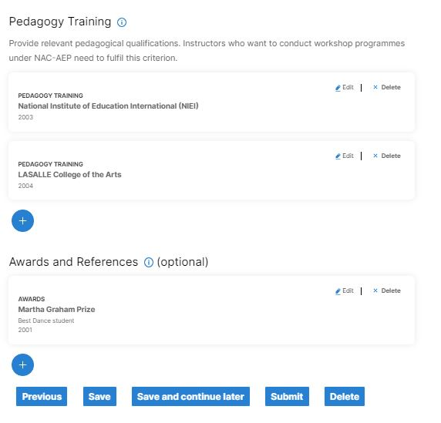
Fig.19 Pedagogy Summary Cards

- Awards and References

This section is optional, for you to highlight any outstanding artistic achievements or accolades awarded by local and international organisations, relevant to your role as an artist and educator.
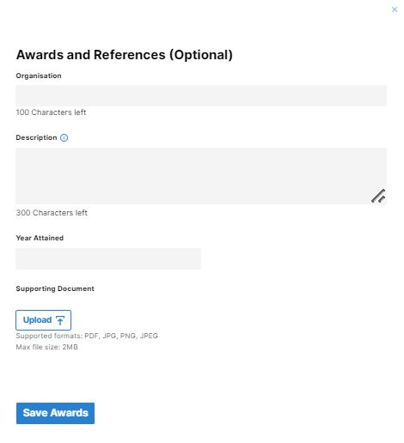
Fig.20 Awards and References
- Organisation
Provide the name of the awarding body/organisation.
- Description
Describe the award or accomplishment received and provide some basic information on the awarding body.
- Year Attained
Provide the year the award was attained.
- Upload of Supporting Documents
Please attach/upload a copy of your certificate(s) by clicking on the blue ‘Upload’ button. Supported formats: PDF, JPG, PNG, JPEG. Max file size: 2MB.
Remember to save your details/progress by clicking on the ‘Save Awards’ button. You will be brought back to the Portfolio page. A summary card of your details will be displayed. To make edits, click on the ‘Edit’ pencil icon.
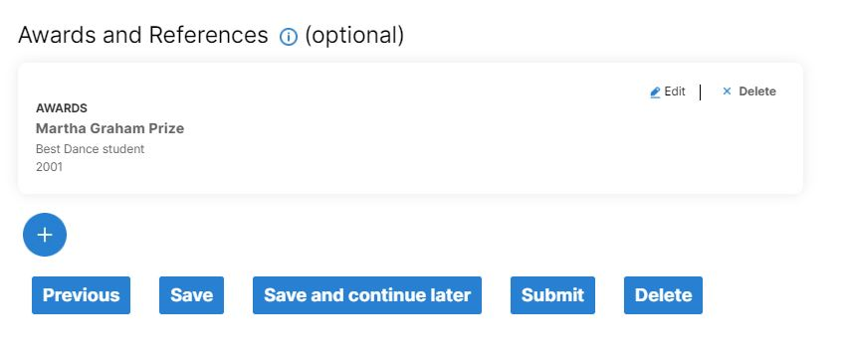
Fig. 21 Awards Summary Cards

Final Steps

- Submission

Check your details. If satisfied, click on the ‘Submit’ button. You will be brought back to the Portfolio page with statement ‘Your portfolio draft is pending NAC’s review’.

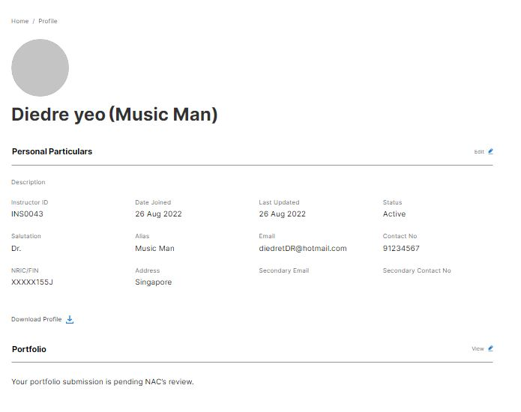
Fig.22 Submission pending NAC’s review

Please note that you will not be able to edit your portfolio once you have submitted. You can view the submission by clicking on the ‘View’ pencil icon.

- Draft

To edit details and continue later, click on ‘Save and continue later’. You will be brought back to the Portfolio page with statement ‘Your portfolio draft is pending submission’. To edit, click on the blue ‘Edit’ pencil icon.

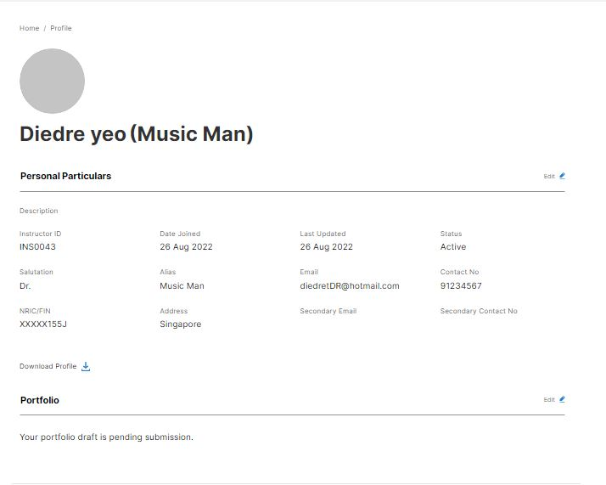
Fig.23 Pending Submission
- Withdrawing a submission

To withdraw your submission, click on the blue ‘View’ pencil icon.

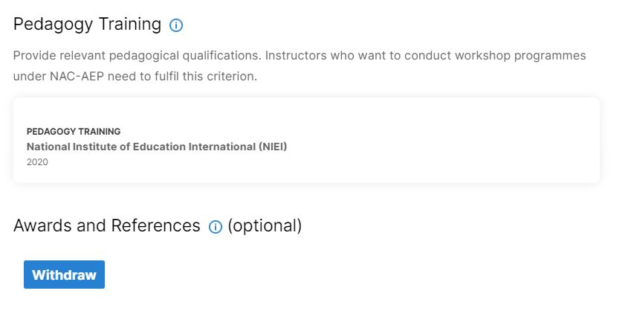
Fig. 24 Withdrawing a submission

A pop-up Confirmation box will appear. Click on ‘Proceed’ to confirm and withdraw the submission. Click on ‘Cancel’ if you do not wish to withdraw.

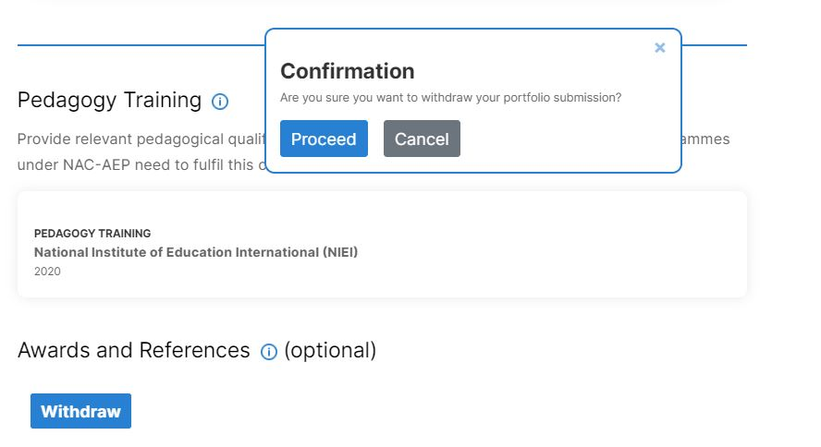
Fig.25 Confirmation of withdrawal

Once withdrawn, an acknowledgement pop-up will be displayed. An email confirmation will also be sent to the registered email address.

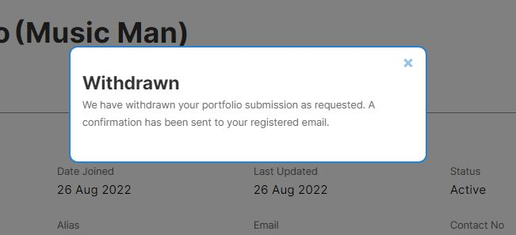
Fig. 26 Acknowledgement of Withdrawal
- Tagging of instructors by providers

Please allow up to two weeks for your submission to be processed. Once processed, you should inform the provider(s) so that he/she/they can tag you to their respective approved programmes. You can accept or decline the tagging by the provider(s). For more information on tagging of instructors, please refer to p.10-12 in the User Guide for Instructor Tagging.


Annex A - Art Form Sub-Genre List
Dance | Ballet  Ballroom  Broadway  Choreography  Contemporary  Creative Movement  Flamenco  Funk  Hip-hop/K-pop  Interpretive  Jazz  Traditional Chinese  Traditional Malay  Traditional Indian  Tap  Urban | Theatre | General Drama skills/Acting  Physical Theatre  Readers' Theatre  Devising/Improvisation  Forum Theatre  Playback Theatre  Technical Theatre skills  Chinese Opera  Western Opera  Traditional Chinese  Traditional Malay  Traditional Indian  Shakespearean  Directing  Play/Script writing  Puppetry making & Skills
Literary Arts | Graphic Novels  Journalism  Literary Criticism  Micro /Flash Fiction/Short stories  Performance Poetry/Spoken Word  Non-fiction Writing  Translation/Editing  Poetry  Publishing  Singlit  Script Analysis  Storytelling | Digital Media | 3D Modelling/Printing  Animation  Architecture  Filmmaking  Design  Photography  Videography
Music | Appreciation/History  Chamber Music  DJ/Turntable/Beatbox  EDM/Hip-Hop  Film/Soundtrack  Guitar/Ukulele  Harmonica  Jazz  Music Tech/DAW/Recording  Music Theory/Writing/Arranging  Opera/Musicals  Orchestra  Percussion  Piano/Keyboard/Harp  Pop/Rock  Singapore/Heritage/Xinyao  Strings  Traditional Chinese  Traditional Indian  Traditional Malay  Vocal/A cappella  Woodwind/Brass  World Music | Visual Arts | Art History/Theory  Batik  Ceramics  Chinese Ink  Collage  Comics/Manga/Caricature  Curation  Drawing  Graffiti  Installation  Metal Tooling  Mixed Media  Painting  Performance Art  Printmaking  Product Design  Sand Art  Sculpture  Storyboarding  Textile

